**BITCOIN’S STOCK TO FLOW MODEL**

Stock to flow model(STF) in simple terms is used to measure the valuation of a commodity with its level of abundance, while the stock to flow ratio, is the amount of existing reserves of a commodity to its rate of supply (The higher the STF ratio the lower the rate of supply and vice versa). STF is normally applied to natural resources like Gold, but some people seem it a good fit to determine the valuation of bitcoin.

Why the STF model is used as a valuation for bitcoin; This model compares bitcoin to scarce commodities like gold, because the amount of gold in reserves cannot be significantly increased considering its low but constant yearly supply, similarly bitcoin is also relatively scarce due to it being relatively difficult to produce and its limited supply flow, bitcoin is also said to have its supply halved every 4 years and maximum supply is capped at 21 million coins. But it makes sense to note that the valuation of a product should not only be determined by its scarcity.

Why the STF model is a bad model;

Firstly, bitcoin’s valuation comparison to that of gold. According to advocates of the STF of bitcoin, Scarcity means having limited new supply of a commodity, which invariably means an increase in the steady supply of the commodity would lead to a decrease in the price of the commodity.

But note that the market capitalization of Gold has changed in value from $60 Billion to $9 Trillion, all at the STF range of 60-80, showed in the chart below. This intuitively means other factors other than the STF ratio lead to an increase in Gold’s USD valuation.

It is also important to note that there are other cryptocurrencies that utilize bitcoin’s code and have the same supply schedule as bitcoin and everyone understands that their STF values have nothing to do with their current or future valuation.

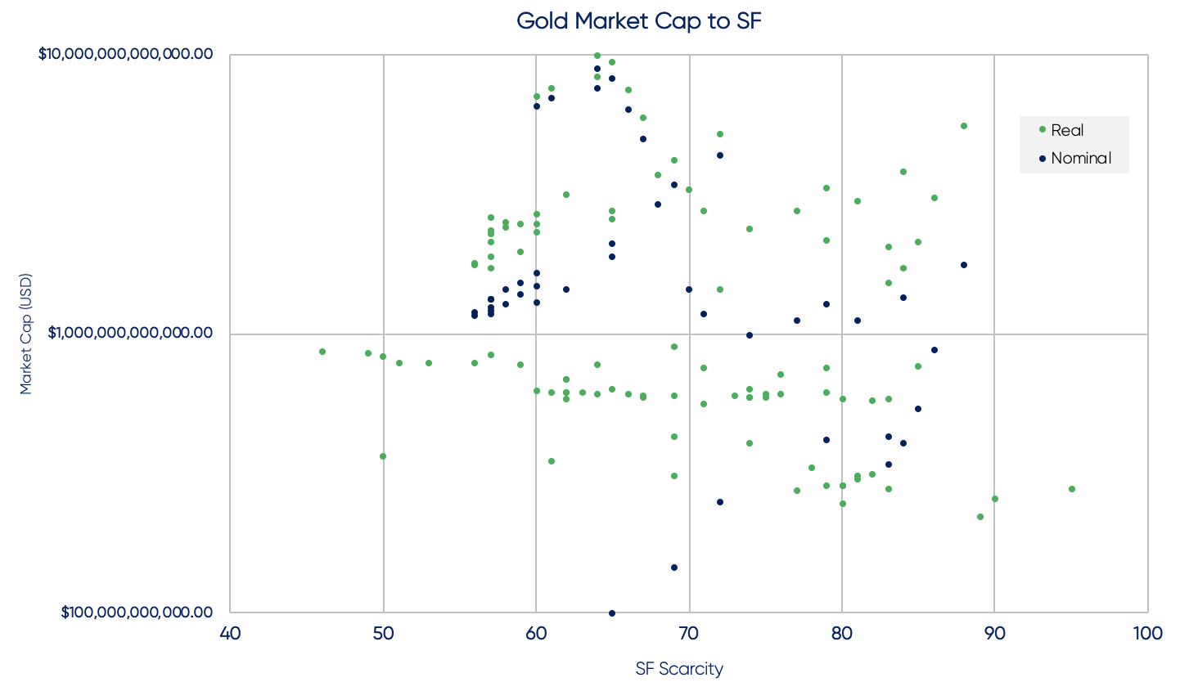

Moreover, the volatility of an asset should be taken into account, If the volatility of an asset is predictable to some extent, it’s model would become more reliable. But the price of bitcoin is mainly self-regulated on the open market by users, buyers and spectators and combined with its relatively low liquidity, causes bitcoin to be more prone to price spikes and volatility than other assets.

Another important factor that undermines the STF model, is the occurrence of a Black Swan event, especially with models that depend on historical data to determine the valuation of an asset. Models like STF are not exempted from these unknown events that historical data cannot predict.

In conclusion, when considering the valuation of assets like bitcoin, 100% trust in models like STF shouldn’t be considered, because the model accommodates to many uncertainties and in my opinion, advocates of the STF model for bitcoin are indirectly trying to convince people on the possibility of an increase in the worth of bitcoin in the future, which may or may not be true.